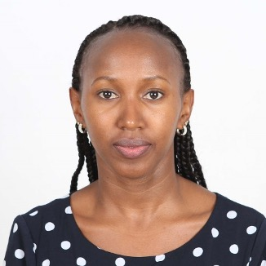

# Education and Professional Designations

* Associate of the Chartered Insurance Institute (ACII)
* Associate in Risk Management – Enterprise Risk (ARM-E)
* University of Nairobi – Bachelor of Commerce - Insurance

# Experience

Gladys joined SRS in September 2021. Gladys began her captive management career in 2011 with Willis Towers Watson Cayman where she was the Insurance Officer with responsibility for overseeing the Insurance programs of all captives under management. Prior to moving to Cayman from her native country Kenya, she had a stint in risk management and brokerage and was previously as Assistant Service Manager at Aon where she managed a portfolio of large corporate clients for 4 years. Prior to that, she worked with an independent insurance broker for 2 years.

# Affiliations

* Associate of the Chartered Insurance Institute

Current Responsibility

Gladys’ primary responsibility is review of insurance and underwriting matters for captive companies under management, ensuring that they are operating within the parameters of the Insurance Law and approved business plans. She is responsible for preparation and review of insurance documentation for client accounts working in collaboration with account managers to assist on insurance specific tasks.

Gladys

Gathua

Account Executive- Insurance,

SRS Cayman

Contact Information

Caribbean Plaza

2nd Floor, North Building

878 West Bay Road

P.O. Box 1159

Grand Cayman, KY1-1102

Cayman Islands

Tel: (345) 623-4657

Fax: (345) 946-6612

[gladys.gathua@strategicrisks.com](http://gladys.gathua@strategicrisks.com)