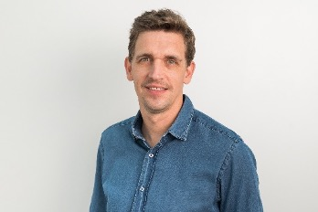

# Education and Professional Designations

* Master’s Degree in Finance, Grenoble Ecole de Management/Graduate School of Business
* Degree in Business Administration and Management, IUT Nancy Charlemagne
* Licensed Manager of reinsurance companies in Luxembourg, issued by the Minister of Finance
* Member of Compliance Professional Group (ALCO)
* English
* French
* Spanish

# Experience

Maxime was formerly the Chief Operating Officer of Risk and Reinsurance Solutions 2RS for eight years, where he held a variety of leadership roles and had responsibility for leading teams in all aspects of captive management, risk management, compliance and business development. He also held mandates as licensed manager and/or director for a significant number of reinsurance captives in Luxembourg and France.

Prior to that, Maxime was a Financial Controller for PayPal HQ, Treasury Manager at Eurowatt HQ, and Senior Manager in Big 4 (Paris & Luxembourg).

Maxime

Schons

Managing Director, European Finance & Compliance

SRS Europe

Contact Information

Tel: +352 621 257 288

[maxime.schons@strategicrisks.com](http://maxime.schons@strategicrisks.com)

Current Responsibility

Maxime holds the position of Managing Director, European Finance and Compliance.

He will also serve on the Executive Committee of SRS Europe Operations and be appointed to the SRS Europe Board of Directors.